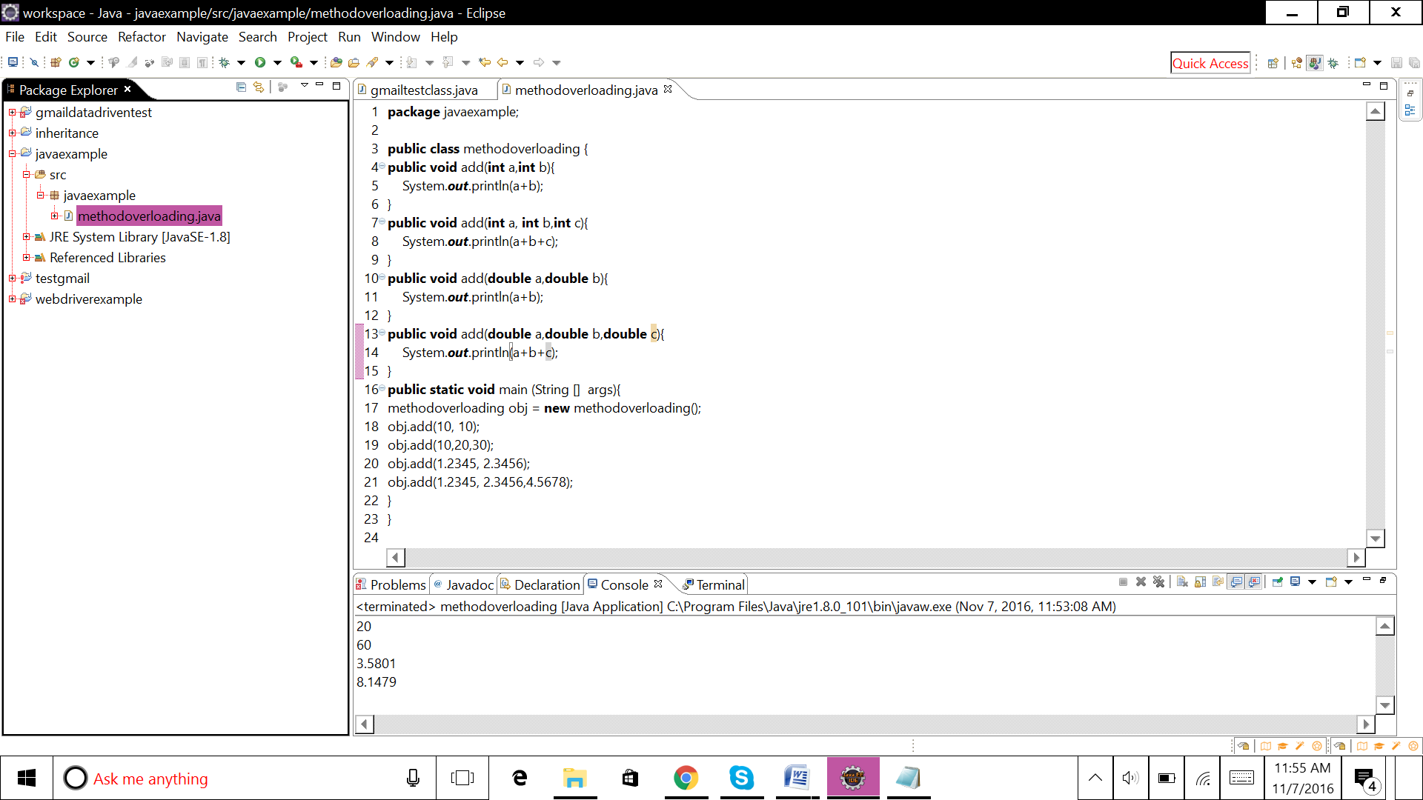

Program:

**package** javaexample;

**public** **class** methodoverloading {

**public** **void** add(**int** a,**int** b){

System.***out***.println(a+b);

}

**public** **void** add(**int** a, **int** b,**int** c){

System.***out***.println(a+b+c);

}

**public** **void** add(**double** a,**double** b){

System.***out***.println(a+b);

}

**public** **void** add(**double** a,**double** b,**double** c){

System.***out***.println(a+b+c);

}

**public** **static** **void** main (String [] args){

methodoverloading obj = **new** methodoverloading();

obj.add(10, 10);

obj.add(10,20,30);

obj.add(1.2345, 2.3456);

obj.add(1.2345, 2.3456,4.5678);

}

}

output

20

60

3.5801

8.1479